|  |  |
| --- | --- |
|  |  |

**Faculty of Technology and Engineering**

**Chandubhai S Patel Institute of Technology**

**Department of Computer Science & Engineering**

**PRACTICAL – 1**

Roll no.: Date:    /    /

|  |  |  |  |  |  |
| --- | --- | --- | --- | --- | --- |
| Academic Year | : | 2024-25 | Semester | : | 4 |
| Course code | : | CSE207 | Course name | : | Design and Analysis of Algorithms |

**AIM:**  Implement and analyze algorithms using iterative and recursive approaches for the problems given below.

|  |  |
| --- | --- |
| 1.1 | Find the factorial of a given number. |
| 1.2 | Print the Fibonacci sequence up to the given number. |

**1.1.1 (a) Data table:  factorial with iterative approach**

|  |  |  |  |
| --- | --- | --- | --- |
| **Input Size** | **No. of Primitive Operation** | **Theoretical Complexity** | **Practical Complexity with Equation** |
| 0 | 4 | O(n) | y=x+4 |
| 5 | 9 |
| 10 | 14 |
| 15 | 19 |
| 20 | 24 |
| 25 | 29 |
| 30 | 34 |
| 35 | 39 |
| 40 | 44 |
| 45 | 49 |

**1.1.1 (b) Line Chart:  factorial with iterative approach**

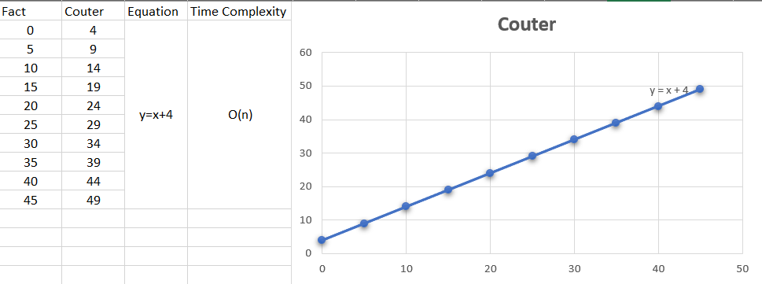

**1.1.2(a) Data table:  factorial with recursive approach**

|  |  |  |  |
| --- | --- | --- | --- |
| **Input Size** | **No. of Primitive Operation** | **Theoretical Complexity** | **Practical Complexity with Equation** |
| 0 | 5 | O(n) | y=1.9x+3.69 |
| 5 | 13 |
| 10 | 23 |
| 15 | 33 |
| 20 | 43 |
| 25 | 53 |
| 30 | 63 |
| 35 | 73 |
| 40 | 83 |
| 45 | 93 |

**1.1.2 (b) Line Chart:  factorial with recursive approach**

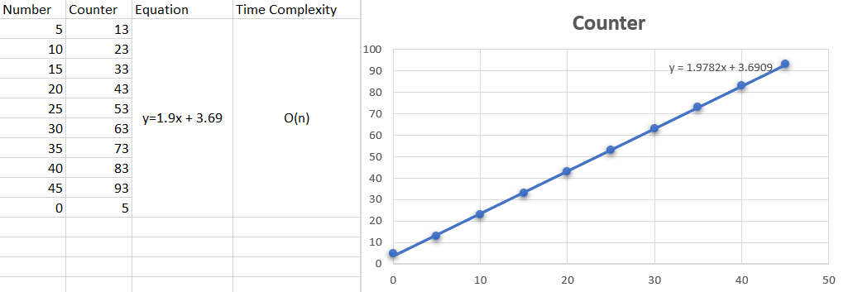

**1.2.1 (a) Data table:  Fibonacci with iterative approach**

|  |  |  |  |
| --- | --- | --- | --- |
| **Input Size** | **No. of Primitive Operation** | **Theoretical Complexity** | **Practical Complexity with Equation** |
| 0 | 8 | O(n) | y=x+8 |
| 5 | 13 |
| 10 | 18 |
| 15 | 23 |
| 20 | 28 |
| 25 | 33 |
| 30 | 38 |
| 35 | 43 |
| 40 | 48 |
| 45 | 53 |

**1.2.1 (b) Line Chart:  Fibonacci with iterative approach**

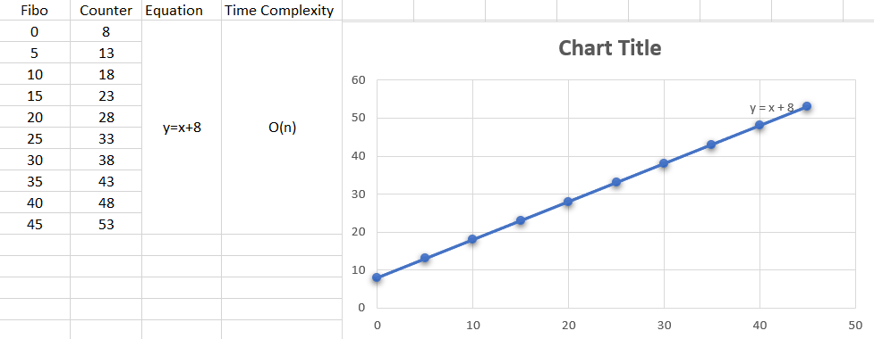

**1.2.2 (a) Data table:  Fibonacci with recursive approach**

|  |  |  |  |
| --- | --- | --- | --- |
| **Input Size** | **No. of Primitive Operation** | **Theoretical Complexity** | **Practical Complexity with Equation** |
| 0 | 7 | O(2^n) | y=6.5e^0.5x |
| 1 | 10 |
| 2 | 17 |
| 4 | 47 |
| 6 | 129 |
| 8 | 347 |
| 10 | 921 |
| 12 | 2427 |
| 14 | 6373 |
| 16 | 16707 |

**1.2.2 (b) Line Chart:  Fibonacci with recursive approach**

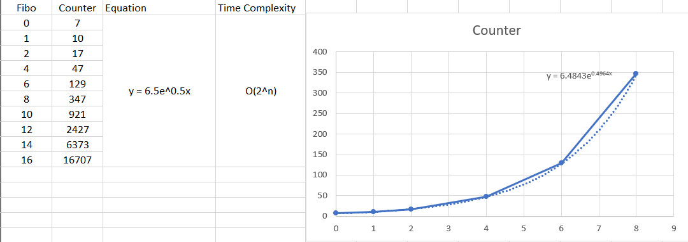

**Conclusion:**

|  |  |
| --- | --- |
|  |  |

**Faculty of Technology and Engineering**

**Chandubhai S Patel Institute of Technology**

**Department of Computer Science & Engineering**

**Performa for PRACTICAL – 1**

Roll no.: Date:    /    /

|  |  |  |  |  |  |
| --- | --- | --- | --- | --- | --- |
| Academic Year | : | 2024-25 | Semester | : | 4 |
| Course code | : | CSE207 | Course name | : | Design and Analysis of Algorithms |

**AIM:**  Implement and analyze algorithms using iterative and recursive approaches for the problems given below.

|  |  |
| --- | --- |
| 1.1 | Find the factorial of a given number. |
| 1.2 | Print the Fibonacci sequence up to the given number. |

**Answer the following Questions:**

1. What are the limitations of using recursion for large inputs in the Fibonacci sequence?

1. Compare the time complexity of the recursive and iterative versions of the above problems. Which one is more efficient in terms of time and space?
2. Discuss the scenario(s) where recursive approach is preferable over iterative approach?
3. Why does recursion generally use more memory compared to iteration?